# Release Notes

Following Items are released

* Coolest-hour-1.0-RELEASE.jar
* Src

# Execution Instructions

Minimum Java Version 8 is required. This application has been tested on

Ubuntu 18.04 , Java 8

Windows 10, Java 10

To execute this application, execute the jar and provide the zipcode (only U.S) for which temperatures for tomorrow are expected.

e.g. : java -jar coolest-hour-1.0-RELEASE.jar 10001 returns the temperature report for tomorrow in New York.

The report highlights the coolest hour

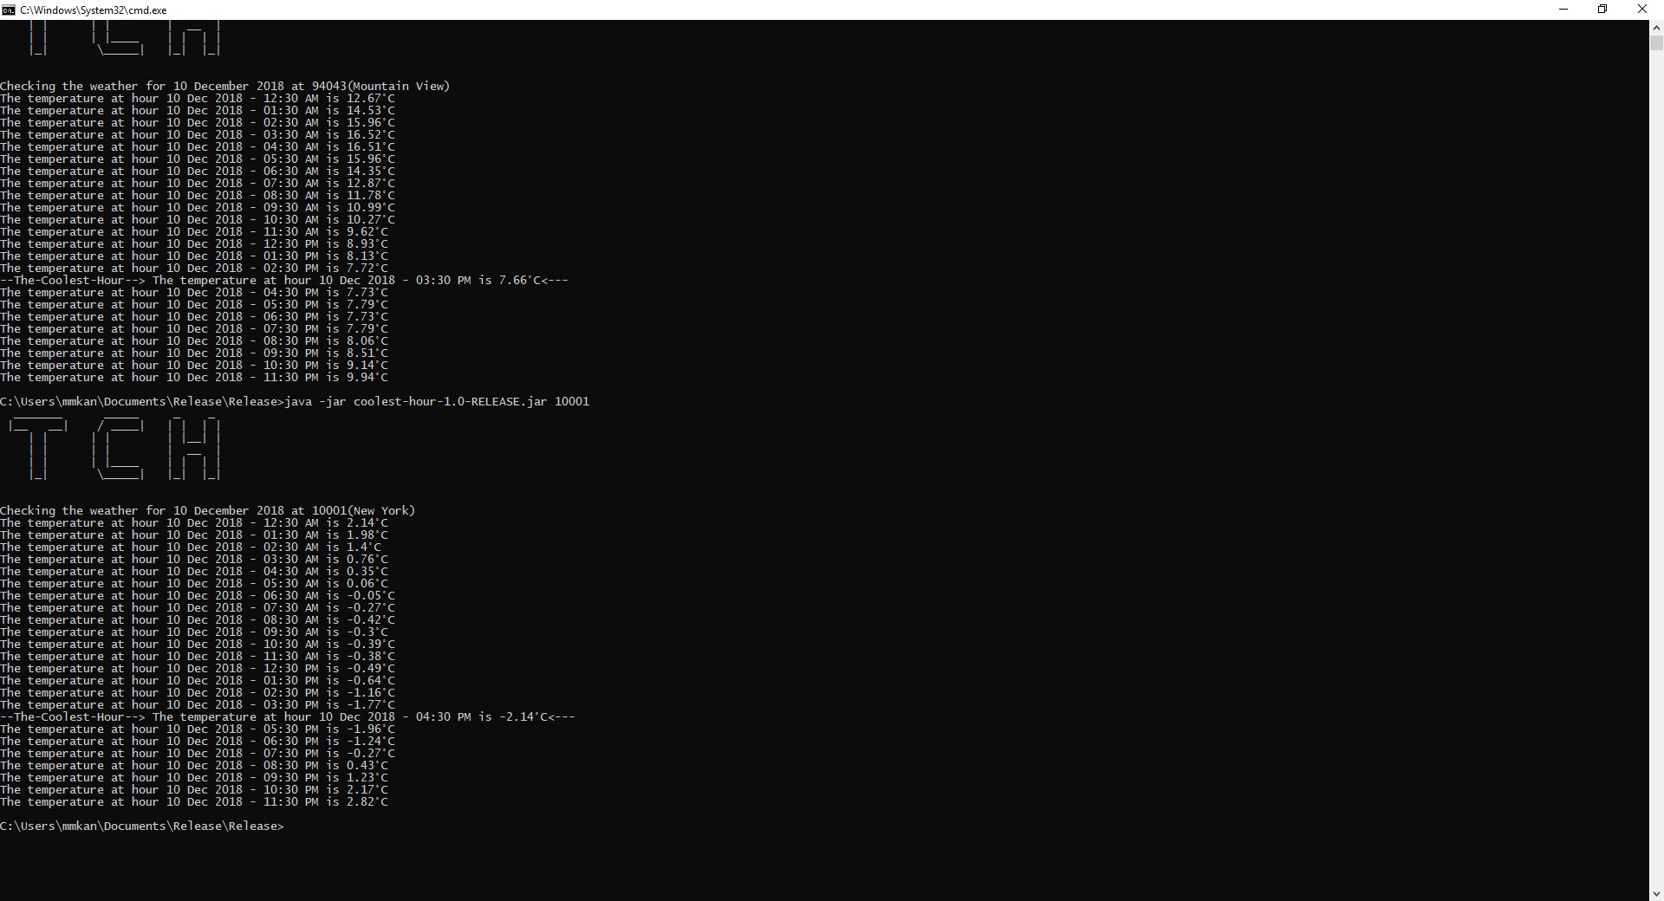

The zipcode can be defaulted in application.properties in src, and at the time of release it is set to 94043

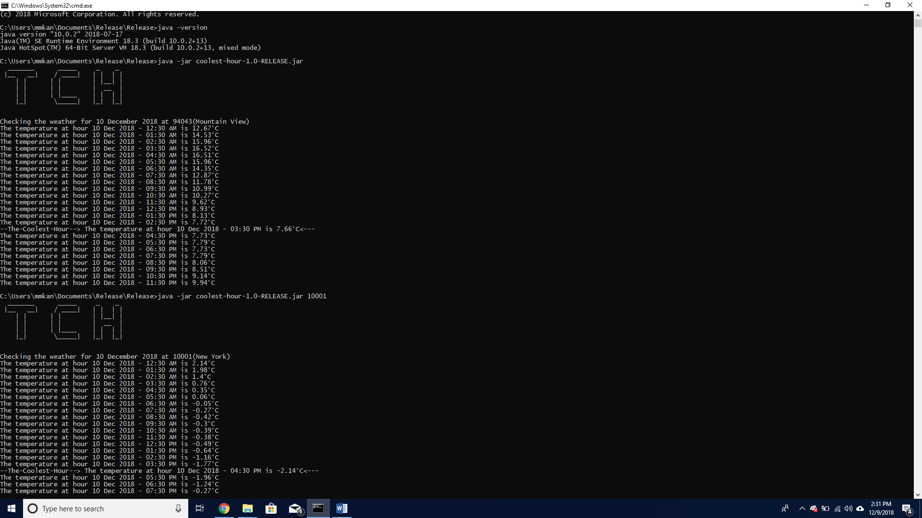

# Powering APIs

This application makes use of two APIs

* Accuweather API : to validate and fetch geographical details from zipcode
* DarkSky API : to fetch temperature details for tomorrow

The keys provided in application.properties are free version and can be used only for a limited times in a day.

# Technical Architecture

The application follows Spring-Boot MVC Architecture.

The main class is : CoolestHourApplication

which invokes different services to get the job done

# Developer Details

Name : Mohit Kanwar

Email : [m.m.kanwar@gmail.com](mailto:m.m.kanwar@gmail.com)

Ph: +91-858-883-2476